**Assignment No.- 1**

**Question 1**

1. Create a blank file named "myfile"

2. Open "myfile" in vi editor

3. Write your name, address, email id, phone number and blood group in 5 different lines

4. Build one single expression to see the line with your name and blood group in myfile

1. **Create a blank file named "myfile" .**



1. **Open "myfile" in vi editor .**

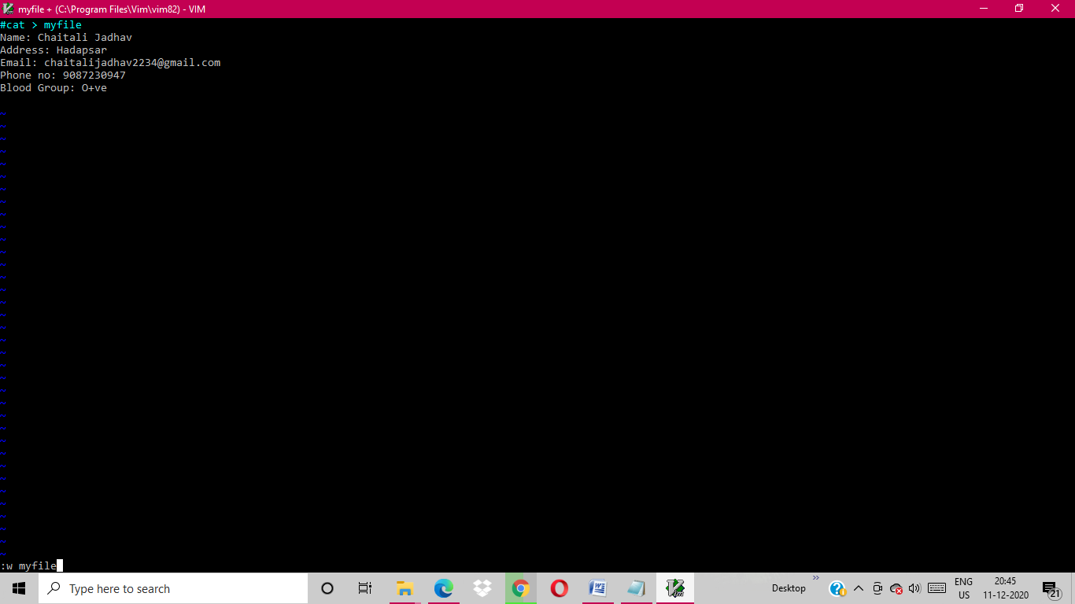

1. **Write your name, address, email id, phone number and blood group in 5 different lines.**

